

**OFFICE OF THE PRESIDENT**

**TO : ALL CONCERNED July 31, 2020**

**SUBJECT : USJ-R Facebook**

As we venture into the new normal, all colleges, departments and offices of the university have been operating and maintaining their respective official Facebook pages.

The official Institutional Facebook page has been serving as our primary portal for the official announcements of the university, updates and for other relevant contents.

All these pages have been serving as our platforms to connect and communicate with our students, alumni and other stakeholders.

With over 40 official Facebook pages under the USJ-R brand, it is imperative that we share a common brand identity by starting to observe the following:

* To primarily use our university colors of green and yellow gold (color hex codes for photo editor: Green - #114224, Yellow Gold-#f6ad10) when coming up with communication materials or content designs for posting
* To use the high definition full color and unicolor university seal in your layouts. You may visit this link <https://drive.google.com/drive/folders/1iazf1AiIkMSYpWEr6T6FYKL45JUYueVM?usp=sharing> to access the file in our cloud.

Having these basic characteristics projected in our Facebook Pages and even in our other social media platforms will immediately present the impression that these are USJ-R legitimate accounts expected to be managed with credibility.

As we usher the entire Josenian community to a new school year, we have prepared a video clip on how USJ-R can be of service in the online landscape. Here is the link to access the video clip: <https://drive.google.com/file/d/1zgfNfOfUkmB4lSmjU9wzXYUg7mbeCPbE/view?usp=sharingLooking>

Kindly use this video as the cover video of your Page or as a pinned post. Here is the proposed caption if you prefer for the posting of the video clip:

Your virtual Josenian community is here!

We are here to #REACH4You as we venture into the new normal.

Do everything online – access our primary online portal, enroll, transact, learn and be updated.

Continue your formal education while staying safe at the comforts of your home.

To help you, we have put in one place all you need to know about the new academic year including our list of programs and helplines:

<https://usjr.edu.ph/online-enrollment/>

#TakingYouFORWARDsince1947

Thank you for your attention and cooperation. Adelante!

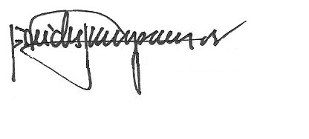

REV. FR. CRISTOPHER C. MASPARA, OAR President

/bvs